Digital video aerial surveys of seabirds at Galloper Extension:

March 2019 to February 2021

Flight height analysis

# Results

## Survey effort

## Flying birds

The total number of flying birds measured within the survey area and those taken forward for flight height estimation are presented in Tables - . A minimum number of 25 reflections is deemed suitable to run flight height analysis. The current sample size of reflection data for each equivalent species is presented alongside. Any differences in the total number of birds measured and those presented in results will be due to removal of outlier values during the analysis process.

### Kittiwake

Table : Total number of flying kittiwake measured and estimated within the survey area in year 1.

| **Month** | **Survey** | **Measured birds** | **Est FH** | **% estimated** | **Reflection n** |
| --- | --- | --- | --- | --- | --- |
| March 2019 | S01 | 65 | 41 | 63.1 | 337 |
| April 2019 | S01 | 31 | 27 | 87.1 | 337 |
| May 2019 | S01 | 34 | 31 | 91.2 | 337 |
| June 2019 | S01 | 39 | 20 | 51.3 | 337 |
| June 2019 | S02 | 12 | 12 | 100.0 | 337 |
| July 2019 | S01 | 15 | 11 | 73.3 | 337 |
| August 2019 | S02 | 7 | 6 | 85.7 | 337 |
| September 2019 | S01 | 9 | 4 | 44.4 | 337 |
| December 2019 | S01 | 34 | 21 | 61.8 | 337 |
| January 2020 | S01 | 44 | 34 | 77.3 | 337 |
| February 2020 | S01 | 38 | 32 | 84.2 | 337 |

Table : Total number of flying kittiwake measured and estimated within the survey area in year 2.

| **Month** | **Survey** | **Measured birds** | **Est FH** | **% estimated** | **Reflection n** |
| --- | --- | --- | --- | --- | --- |
| March 2020 | S02 | 7 | 4 | 57.1 | 337 |
| April 2020 | S01 | 4 | 2 | 50.0 | 337 |
| May 2020 | S01 | 11 | 10 | 90.9 | 337 |
| June 2020 | S01 | 24 | 23 | 95.8 | 337 |
| July 2020 | S01 | 14 | 14 | 100.0 | 337 |
| August 2020 | S01 | 13 | 12 | 92.3 | 337 |
| September 2020 | S01 | 1 | 1 | 100.0 | 337 |
| December 2020 | S01 | 23 | 16 | 69.6 | 337 |
| February 2021 | S01 | 97 | 69 | 71.1 | 337 |

### Gannet

Table : Total number of flying gannet measured and estimated within the survey area in year 1.

| **Month** | **Survey** | **Measured birds** | **Est FH** | **% estimated** | **Reflection n** |
| --- | --- | --- | --- | --- | --- |
| March 2019 | S01 | 5 | 4 | 80 | 341 |
| April 2019 | S01 | 3 | 3 | 100 | 341 |
| May 2019 | S01 | 1 | 1 | 100 | 341 |
| June 2019 | S01 | 2 | 1 | 50 | 341 |
| June 2019 | S02 | 2 | 1 | 50 | 341 |
| August 2019 | S02 | 6 | 6 | 100 | 341 |
| September 2019 | S01 | 1 | 1 | 100 | 341 |
| December 2019 | S01 | 1 | 1 | 100 | 341 |
| January 2020 | S01 | 1 | 1 | 100 | 341 |
| February 2020 | S01 | 7 | 7 | 100 | 341 |

Table : Total number of flying gannet measured and estimated within the survey area in year 2.

| **Month** | **Survey** | **Measured birds** | **Est FH** | **% estimated** | **Reflection n** |
| --- | --- | --- | --- | --- | --- |
| March 2020 | S02 | 1 | 1 | 100 | 341 |
| April 2020 | S01 | 1 | 0 | 0 | 341 |
| August 2020 | S01 | 7 | 7 | 100 | 341 |
| December 2020 | S01 | 2 | 2 | 100 | 341 |
| February 2021 | S01 | 8 | 6 | 75 | 341 |

### Lesser black-backed gull

Table : Total number of flying lesser black-backed gull measured and estimated within the survey area in year 1.

| **Month** | **Survey** | **Measured birds** | **Est FH** | **% estimated** | **Reflection n** |
| --- | --- | --- | --- | --- | --- |
| March 2019 | S01 | 3 | 1 | 33.3 | 34 |
| March 2019 | S02 | 12 | 11 | 91.7 | 34 |
| April 2019 | S01 | 6 | 6 | 100.0 | 34 |
| April 2019 | S02 | 6 | 6 | 100.0 | 34 |
| May 2019 | S01 | 6 | 5 | 83.3 | 34 |
| May 2019 | S02 | 9 | 8 | 88.9 | 34 |
| June 2019 | S01 | 28 | 22 | 78.6 | 34 |
| June 2019 | S02 | 27 | 26 | 96.3 | 34 |
| July 2019 | S01 | 10 | 10 | 100.0 | 34 |
| July 2019 | S02 | 56 | 53 | 94.6 | 34 |
| August 2019 | S01 | 3 | 2 | 66.7 | 34 |
| August 2019 | S02 | 3 | 3 | 100.0 | 34 |
| September 2019 | S01 | 10 | 7 | 70.0 | 34 |
| December 2019 | S01 | 2 | 2 | 100.0 | 34 |

Table : Total number of flying lesser black-backed gull measured and estimated within the survey area in year 2.

| **Month** | **Survey** | **Measured birds** | **Est FH** | **% estimated** | **Reflection n** |
| --- | --- | --- | --- | --- | --- |
| March 2020 | S01 | 1 | 1 | 100.0 | 34 |
| March 2020 | S02 | 4 | 4 | 100.0 | 34 |
| April 2020 | S02 | 10 | 10 | 100.0 | 34 |
| May 2020 | S01 | 10 | 8 | 80.0 | 34 |
| May 2020 | S02 | 1 | 1 | 100.0 | 34 |
| June 2020 | S01 | 37 | 34 | 91.9 | 34 |
| June 2020 | S02 | 13 | 10 | 76.9 | 34 |
| July 2020 | S01 | 7 | 7 | 100.0 | 34 |
| July 2020 | S02 | 4 | 4 | 100.0 | 34 |
| August 2020 | S01 | 3 | 3 | 100.0 | 34 |
| August 2020 | S02 | 3 | 3 | 100.0 | 34 |
| September 2020 | S01 | 4 | 4 | 100.0 | 34 |
| December 2020 | S01 | 5 | 4 | 80.0 | 34 |
| February 2021 | S01 | 3 | 2 | 66.7 | 34 |

### Great black-backed gull

Table : Total number of flying great black-backed gull measured and estimated within the survey area in year 1.

| **Month** | **Survey** | **Measured birds** | **Est FH** | **% estimated** | **Reflection n** |
| --- | --- | --- | --- | --- | --- |
| March 2019 | S01 | 2 | 2 | 100 | 34 |
| March 2019 | S02 | 3 | 3 | 100 | 34 |
| April 2019 | S01 | 3 | 3 | 100 | 34 |
| April 2019 | S02 | 5 | 5 | 100 | 34 |
| May 2019 | S02 | 6 | 6 | 100 | 34 |
| June 2019 | S01 | 2 | 1 | 50 | 34 |
| July 2019 | S02 | 4 | 4 | 100 | 34 |
| September 2019 | S01 | 3 | 3 | 100 | 34 |
| December 2019 | S01 | 1 | 1 | 100 | 34 |

Table : Total number of flying great black-backed gull measured and estimated within the survey area in year 2.

| **Month** | **Survey** | **Measured birds** | **Est FH** | **% estimated** | **Reflection n** |
| --- | --- | --- | --- | --- | --- |
| March 2020 | S01 | 3 | 2 | 66.7 | 34 |
| July 2020 | S02 | 1 | 1 | 100.0 | 34 |
| August 2020 | S02 | 1 | 1 | 100.0 | 34 |
| September 2020 | S01 | 1 | 1 | 100.0 | 34 |
| December 2020 | S01 | 16 | 15 | 93.8 | 34 |

### Herring gull

Table : Total number of flying herring gull measured and estimated within the survey area in year 1.

| **Month** | **Survey** | **Measured birds** | **Est FH** | **% estimated** | **Reflection n** |
| --- | --- | --- | --- | --- | --- |
| March 2019 | S01 | 1 | 0 | 0.0 | 127 |
| March 2019 | S02 | 2 | 2 | 100.0 | 127 |
| April 2019 | S02 | 1 | 1 | 100.0 | 127 |
| June 2019 | S01 | 3 | 2 | 66.7 | 127 |
| June 2019 | S02 | 3 | 3 | 100.0 | 127 |
| August 2019 | S01 | 6 | 5 | 83.3 | 127 |
| September 2019 | S01 | 1 | 1 | 100.0 | 127 |
| December 2019 | S01 | 1 | 1 | 100.0 | 127 |
| January 2020 | S01 | 1 | 1 | 100.0 | 127 |

Table : Total number of flying herring gull measured and estimated within the survey area in year 2.

| **Month** | **Survey** | **Measured birds** | **Est FH** | **% estimated** | **Reflection n** |
| --- | --- | --- | --- | --- | --- |
| April 2020 | S01 | 2 | 2 | 100.0 | 127 |
| April 2020 | S02 | 2 | 2 | 100.0 | 127 |
| June 2020 | S02 | 1 | 1 | 100.0 | 127 |
| August 2020 | S02 | 1 | 1 | 100.0 | 127 |
| December 2020 | S01 | 3 | 2 | 66.7 | 127 |
| February 2021 | S01 | 1 | 1 | 100.0 | 127 |

## Flight Height

Estimates of mean flight height for the minimum, mean and maximum flight height scenarios are presented for each species in Tables - . The estimate of the proportion of birds at PCH for each scenario is based on the number of individual birds whose mean flight height fell within the rotor swept area.

The distribution of these heights are presented as box plots for each species in Figures , , , , , , , , , . The grey boxes represent the middle 50% of the estimated flight heights for each scenario, and the mean of the population is indicated by the black dot. The distributions of flight height are also represented in ordered dot plots in Figures , , , , , , , , and .

The spatial variation in flight heights are represented in Figures , , , , , , , , and .

All but one of the mean heights for either of the two species ranged below 252m (the maximum rotor height of the smallest turbine specification). As such, the estimated proportions of birds at PCH for the smallest and largest wind turbine scenarios are identical with the exception of the maximum July flight height for gannets.

### Kittiwake

#### Proportion of birds at PCH

Table : Mean height and proportion (%) of kittiwake at PCH in year 1. For flight heights both the mean and the interquartile range (IQR), i.e. the middle 50% of the data, are reported for each of the bootstrapped flight height scenarios.

|  | | | | | | | **Proportion of birds at PCH  (%)** | |
| --- | --- | --- | --- | --- | --- | --- | --- | --- |
| **Year** | **Survey** | **Scenario** | **Sample Size  (n)** | **Mean bootstrapped  height estimate  (m)** | **+/- 95% CI** | **Inter-quartile  range** | **Small Scenario  (32 - 252m)** | **Large scenario  (32 - 322m)** |
| Year 1 | March S01 | Low | 41 | 29.0 | (11.4-46.6) | 0-27.3 | 22.0 | 22 |
| Year 1 | Mean | 39.8 | (20-59.6) | 0-32.7 | 26.8 | 27 |
| Year 1 | High | 56.4 | (34.7-78.1) | 0-81.9 | 48.8 | 49 |
| Year 1 | April S01 | Low | 27 | 15.9 | (0.9-30.9) | 0-0 | 14.8 | 15 |
| Year 1 | Mean | 31.7 | (10.1-53.3) | 0-30.7 | 25.9 | 26 |
| Year 1 | High | 56.4 | (28.9-83.9) | 0.7-71.3 | 48.1 | 48 |
| Year 1 | May S01 | Low | 31 | 8.2 | (2.8-13.6) | 0-9.4 | 12.9 | 13 |
| Year 1 | Mean | 25.8 | (14.7-36.9) | 2.5-52.6 | 29.0 | 29 |
| Year 1 | High | 58.8 | (42.3-75.3) | 24.9-94.3 | 67.7 | 68 |
| Year 1 | June S01 | Low | 20 | 80.2 | (35.1-125.3) | 0-200.5 | 40.0 | 40 |
| Year 1 | Mean | 92.6 | (45.5-139.7) | 0-223.5 | 45.0 | 45 |
| Year 1 | High | 106.4 | (57.4-155.4) | 0-236.5 | 45.0 | 60 |
| Year 1 | June S02 | Low | 12 | 63.5 | (23.7-103.3) | 0-136.7 | 50.0 | 50 |
| Year 1 | Mean | 83.7 | (36.3-131.1) | 0.7-161 | 58.3 | 58 |
| Year 1 | High | 112.7 | (60.6-164.8) | 21.4-188 | 66.7 | 67 |
| Year 1 | July S01 | Low | 11 | 15.5 | (-5.8-36.8) | 0-0.1 | 18.2 | 18 |
| Year 1 | Mean | 32.9 | (1-64.8) | 3-39.3 | 27.3 | 27 |
| Year 1 | High | 70.1 | (31.9-108.3) | 37.6-90.3 | 90.9 | 91 |
| Year 1 | August S02 | Low | 6 | 0.0 | (0-0) | 0-0 | 0.0 | 0 |
| Year 1 | Mean | 1.3 | (0.1-2.5) | 0.1-2.4 | 0.0 | 0 |
| Year 1 | High | 14.3 | (0.7-27.9) | 1.5-18.4 | 16.7 | 17 |
| Year 1 | September | Low | 4 | 93.8 | (2.2-185.4) | 20.6-169.1 | 50.0 | 50 |
| Year 1 | Mean | 102.9 | (6.7-199.1) | 29.9-178 | 75.0 | 75 |
| Year 1 | High | 112.4 | (12.1-212.7) | 41.1-186.2 | 75.0 | 75 |
| Year 1 | December | Low | 21 | 12.2 | (-1.9-26.3) | 0-0 | 14.3 | 14 |
| Year 1 | Mean | 32.4 | (14-50.8) | 4.6-40.8 | 33.3 | 33 |
| Year 1 | High | 72.5 | (49.2-95.8) | 23.6-109.7 | 66.7 | 67 |
| Year 1 | January | Low | 34 | 13.4 | (2.9-23.9) | 0-1.3 | 14.7 | 15 |
| Year 1 | Mean | 33.4 | (17-49.8) | 3.5-40.4 | 32.4 | 32 |
| Year 1 | High | 66.7 | (46.7-86.7) | 23.7-102.2 | 67.6 | 68 |
| Year 1 | February | Low | 32 | 27.8 | (15.5-40.1) | 0-56.4 | 34.4 | 34 |
| Year 1 | Mean | 65.0 | (43.7-86.3) | 7.1-107.3 | 59.4 | 59 |
| Year 1 | High | 104.0 | (79.8-128.2) | 54-151.3 | 84.4 | 84 |

Table : Mean height and proportion (%) of kittiwake at PCH in year 2. For flight heights both the mean and the interquartile range (IQR), i.e. the middle 50% of the data, are reported for each of the bootstrapped flight height scenarios.

|  | | | | | | | **Proportion of birds at PCH  (%)** | |
| --- | --- | --- | --- | --- | --- | --- | --- | --- |
| **Year** | **Survey** | **Scenario** | **Sample Size  (n)** | **Mean bootstrapped  height estimate  (m)** | **+/- 95% CI** | **Inter-quartile  range** | **Small Scenario  (32 - 252m)** | **Large scenario  (32 - 322m)** |
| Year 2 | March S02 | Low | 4 | 12.4 | (-7.2-32) | 0-16.3 | 25.0 | 25 |
| Year 2 | Mean | 40.3 | (-14.6-95.2) | 0-61.3 | 50.0 | 50 |
| Year 2 | High | 57.4 | (-14.9-129.7) | 0-95 | 50.0 | 50 |
| Year 2 | April S01 | Low | 2 | 97.4 | (-93.6-288.4) | 48.7-146.1 | 50.0 | 50 |
| Year 2 | Mean | 113.5 | (-109-336) | 56.8-170.3 | 50.0 | 50 |
| Year 2 | High | 130.6 | (-125.3-386.5) | 65.3-195.9 | 0.0 | 50 |
| Year 2 | May S01 | Low | 10 | 32.1 | (4.8-59.4) | 0-37.3 | 40.0 | 40 |
| Year 2 | Mean | 70.0 | (26.6-113.4) | 7.1-108.3 | 60.0 | 60 |
| Year 2 | High | 115.2 | (70.9-159.5) | 54.8-169 | 90.0 | 90 |
| Year 2 | June S01 | Low | 23 | 12.6 | (0.2-25) | 0-0 | 17.4 | 17 |
| Year 2 | Mean | 34.6 | (13.6-55.6) | 2.6-50.2 | 26.1 | 26 |
| Year 2 | High | 75.6 | (48.6-102.6) | 33.8-115.2 | 73.9 | 74 |
| Year 2 | July S01 | Low | 14 | 12.5 | (-4.6-29.6) | 0-0 | 14.3 | 14 |
| Year 2 | Mean | 44.5 | (18-71) | 13-60.9 | 42.9 | 43 |
| Year 2 | High | 98.9 | (65.6-132.2) | 71.5-135.2 | 85.7 | 86 |
| Year 2 | August S01 | Low | 12 | 33.5 | (0.5-66.5) | 0-41.3 | 25.0 | 25 |
| Year 2 | Mean | 70.3 | (30.5-110.1) | 17.5-115.9 | 58.3 | 58 |
| Year 2 | High | 112.0 | (65.2-158.8) | 57.5-181.5 | 75.0 | 75 |
| Year 2 | September | Low | 1 | 0.0 | (NA-NA) | 0-0 | 0.0 | 0 |
| Year 2 | Mean | 34.8 | (NA-NA) | 34.8-34.8 | 100.0 | 100 |
| Year 2 | High | 94.3 | (NA-NA) | 94.3-94.3 | 100.0 | 100 |
| Year 2 | December | Low | 16 | 37.4 | (9.9-64.9) | 0-73.5 | 31.2 | 31 |
| Year 2 | Mean | 50.6 | (17.8-83.4) | 0-92.2 | 37.5 | 38 |
| Year 2 | High | 66.9 | (32.7-101.1) | 9.3-110.5 | 56.2 | 56 |
| Year 2 | February | Low | 69 | 2.8 | (0.8-4.8) | 0-0 | 2.9 | 3 |
| Year 2 | Mean | 14.3 | (8.9-19.7) | 0-15.6 | 15.9 | 16 |
| Year 2 | High | 37.8 | (28.5-47.1) | 0-57.6 | 46.4 | 46 |

#### Flight height ranges

For interpretation of the following graphs, see Section 3.2.

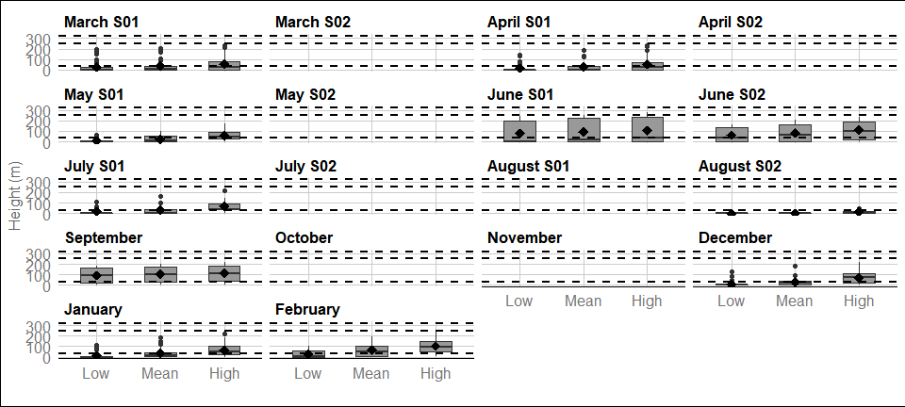

Figure : Distribution of kittiwake flight heights from minimum (2.5th percentile), mean and maximum (97.5th percentile) bootstrapped estimates in year 1. The mean of the population for each distribution is indicated by the black dot, and the middle line represents the median. The grey boxes represent the middle 50% of the data. The dotted lines indicate the minimum and maximum rotor heights of both wind turbine scenarios.

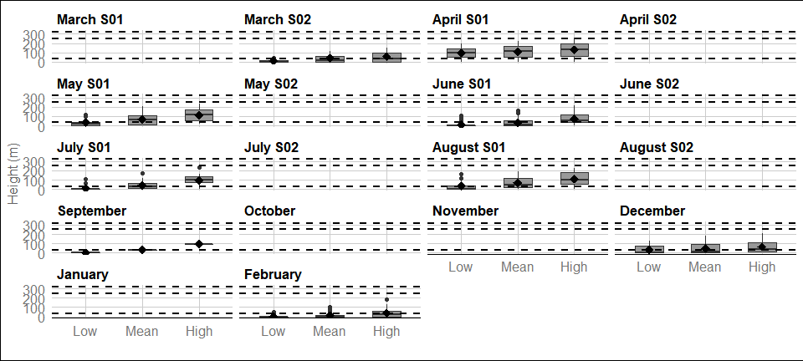

Figure : Distribution of kittiwake flight heights from minimum (2.5th percentile), mean and maximum (97.5th percentile) bootstrapped estimates in year 2. The mean of the population for each distribution is indicated by the black dot, and the middle line represents the median. The grey boxes represent the middle 50% of the data. The dotted lines indicate the minimum and maximum rotor heights of both wind turbine scenarios.

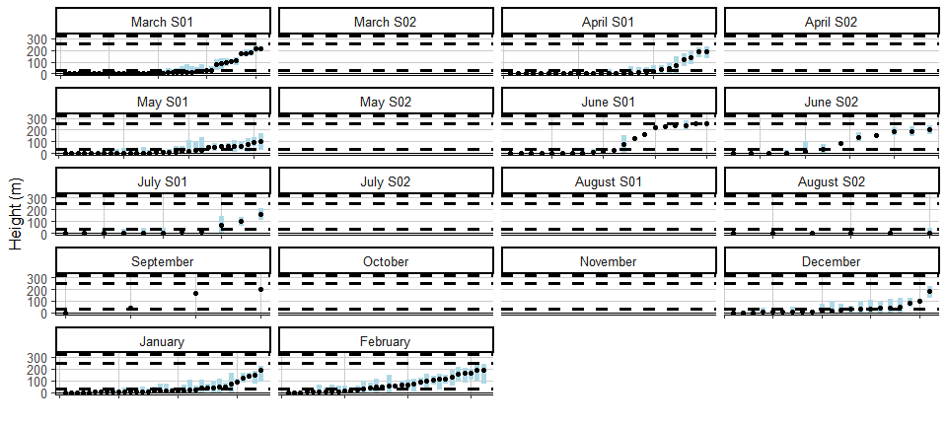

Figure : Ordered height estimates of individual kittiwake in the survey area with minimum and maximum potential height range for both smallest and largest turbine specifications in year1.

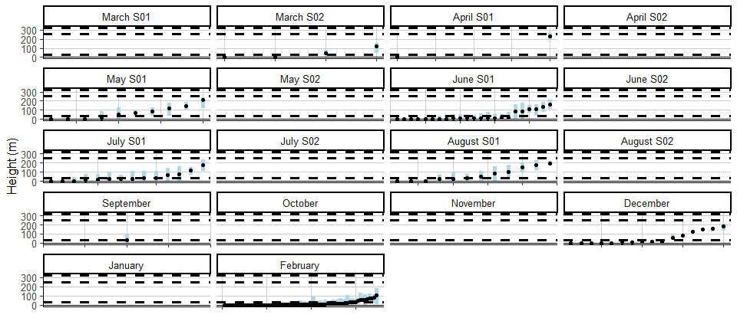

Figure : Ordered height estimates of individual kittiwake in the survey area with minimum and maximum potential height range for both smallest and largest turbine specifications in year2.

#### Spatial variation in flight height

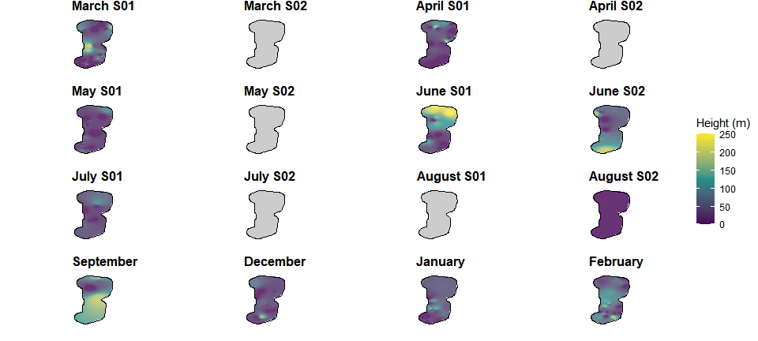

Figure : Two-dimensional spatial variation in estimated mean flight heights of kittiwake in year 1. Flight height estimates were derived using an inverse distance weighted interpolation. Grey plots indicate months were no birds of this species were recorded.

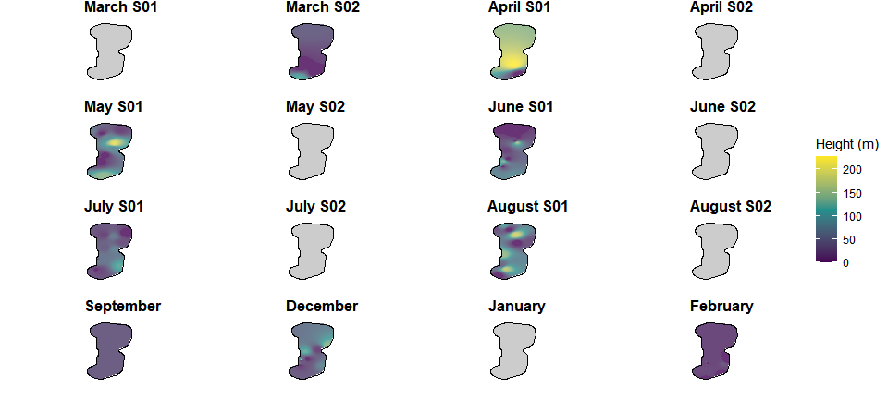

Figure : Two-dimensional spatial variation in estimated mean flight heights of kittiwake in year 2. Flight height estimates were derived using an inverse distance weighted interpolation. Grey plots indicate months were no birds of this species were recorded.

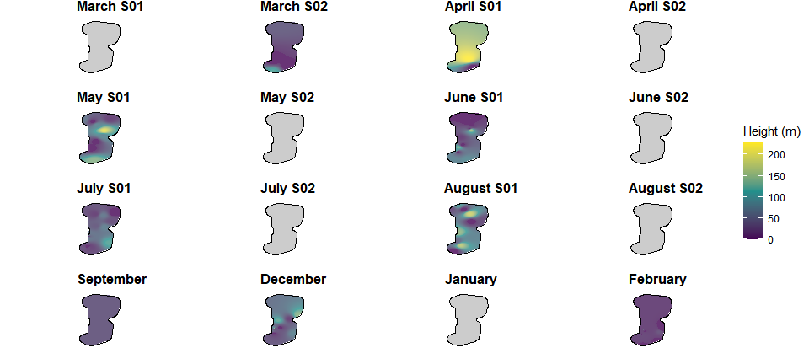

Figure : Two-dimensional spatial variation in estimated mean flight heights of kittiwake in year 2. Flight height estimates were derived using an inverse distance weighted interpolation. Grey plots indicate months were no birds of this species were recorded.

### Gannet

#### Proportion of birds at PCH

Table : Mean height and proportion (%) of gannet at PCH in year 1. For flight heights both the mean and the interquartile range (IQR), i.e. the middle 50% of the data, are reported for each of the bootstrapped flight height scenarios.

|  | | | | | | | **Proportion of birds at PCH  (%)** | |
| --- | --- | --- | --- | --- | --- | --- | --- | --- |
| **Year** | **Survey** | **Scenario** | **Sample Size  (n)** | **Mean bootstrapped  height estimate  (m)** | **+/- 95% CI** | **Inter-quartile  range** | **Small Scenario  (32 - 252m)** | **Large scenario  (32 - 322m)** |
| Year 1 | March S01 | Low | 4 | 142.8 | (45.9-239.7) | 114.7-206.6 | 75.0 | 75 |
| Year 1 | Mean | 164.2 | (53.3-275.1) | 134.4-235.6 | 75.0 | 75 |
| Year 1 | High | 184.7 | (60.9-308.5) | 155.9-261.7 | 25.0 | 75 |
| Year 1 | April S01 | Low | 3 | 31.7 | (-30.5-93.9) | 0-47.6 | 33.3 | 33 |
| Year 1 | Mean | 68.7 | (-21.2-158.6) | 24.4-101.1 | 66.7 | 67 |
| Year 1 | High | 115.1 | (15.7-214.5) | 67.1-153.3 | 100.0 | 100 |
| Year 1 | May S01 | Low | 1 | 38.0 | (NA-NA) | 38-38 | 100.0 | 100 |
| Year 1 | Mean | 94.6 | (NA-NA) | 94.6-94.6 | 100.0 | 100 |
| Year 1 | High | 144.3 | (NA-NA) | 144.3-144.3 | 100.0 | 100 |
| Year 1 | June S01 | Low | 0.0 | (NA-NA) | 0-0 | 0.0 | 0 |
| Year 1 | Mean | 8.3 | (NA-NA) | 8.3-8.3 | 0.0 | 0 |
| Year 1 | High | 34.9 | (NA-NA) | 34.9-34.9 | 100.0 | 100 |
| Year 1 | June S02 | Low | 0.0 | (NA-NA) | 0-0 | 0.0 | 0 |
| Year 1 | Mean | 33.5 | (NA-NA) | 33.5-33.5 | 100.0 | 100 |
| Year 1 | High | 99.2 | (NA-NA) | 99.2-99.2 | 100.0 | 100 |
| Year 1 | August S02 | Low | 6 | 44.9 | (-14.2-104) | 0.2-66.4 | 33.3 | 33 |
| Year 1 | Mean | 62.8 | (1.9-123.7) | 13.7-91.1 | 50.0 | 50 |
| Year 1 | High | 85.3 | (24.1-146.5) | 50-110.7 | 83.3 | 83 |
| Year 1 | September | Low | 1 | 170.7 | (NA-NA) | 170.7-170.7 | 100.0 | 100 |
| Year 1 | Mean | 182.9 | (NA-NA) | 182.9-182.9 | 100.0 | 100 |
| Year 1 | High | 192.1 | (NA-NA) | 192.1-192.1 | 100.0 | 100 |
| Year 1 | December | Low | 0.0 | (NA-NA) | 0-0 | 0.0 | 0 |
| Year 1 | Mean | 0.9 | (NA-NA) | 0.9-0.9 | 0.0 | 0 |
| Year 1 | High | 15.0 | (NA-NA) | 15-15 | 0.0 | 0 |
| Year 1 | January | Low | 0.0 | (NA-NA) | 0-0 | 0.0 | 0 |
| Year 1 | Mean | 11.0 | (NA-NA) | 11-11 | 0.0 | 0 |
| Year 1 | High | 75.0 | (NA-NA) | 75-75 | 100.0 | 100 |
| Year 1 | February | Low | 7 | 53.8 | (-14.6-122.2) | 0-86.7 | 28.6 | 29 |
| Year 1 | Mean | 59.8 | (-14.8-134.4) | 0-101.2 | 28.6 | 29 |
| Year 1 | High | 70.8 | (-6.5-148.1) | 1.2-127 | 42.9 | 43 |

Table : Mean height and proportion (%) of gannet at PCH in year 2. For flight heights both the mean and the interquartile range (IQR), i.e. the middle 50% of the data, are reported for each of the bootstrapped flight height scenarios.

|  | | | | | | | **Proportion of birds at PCH  (%)** | |
| --- | --- | --- | --- | --- | --- | --- | --- | --- |
| **Year** | **Survey** | **Scenario** | **Sample Size  (n)** | **Mean bootstrapped  height estimate  (m)** | **+/- 95% CI** | **Inter-quartile  range** | **Small Scenario  (32 - 252m)** | **Large scenario  (32 - 322m)** |
| Year 2 | March S02 | Low | 1 | 0.0 | (NA-NA) | 0-0 | 0.0 | 0 |
| Year 2 | Mean | 0.0 | (NA-NA) | 0-0 | 0.0 | 0 |
| Year 2 | High | 0.0 | (NA-NA) | 0-0 | 0.0 | 0 |
| Year 2 | August S01 | Low | 7 | 32.0 | (-10.2-74.2) | 0-42.4 | 28.6 | 29 |
| Year 2 | Mean | 40.8 | (-12.1-93.7) | 0-57.9 | 28.6 | 29 |
| Year 2 | High | 49.3 | (-13.7-112.3) | 0-73 | 28.6 | 29 |
| Year 2 | December | Low | 2 | 1.6 | (-1.6-4.8) | 0.8-2.5 | 0.0 | 0 |
| Year 2 | Mean | 42.5 | (-26.1-111.1) | 25-60 | 50.0 | 50 |
| Year 2 | High | 104.3 | (29.4-179.2) | 85.1-123.4 | 100.0 | 100 |
| Year 2 | February | Low | 6 | 39.3 | (-20.3-98.9) | 0-37.8 | 33.3 | 33 |
| Year 2 | Mean | 54.8 | (-15.4-125) | 0-76.7 | 33.3 | 33 |
| Year 2 | High | 74.6 | (-7.7-156.9) | 0-123.1 | 50.0 | 50 |

#### Flight height ranges

For interpretation of the following graphs, see Section 3.2.

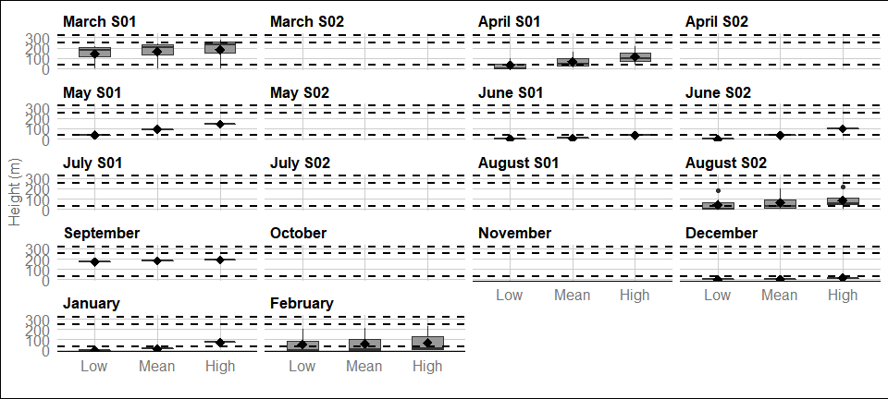

Figure : Distribution of gannet flight heights from minimum (2.5th percentile), mean and maximum (97.5th percentile) bootstrapped estimates in year 1. The mean of the population for each distribution is indicated by the black dot, and the middle line represents the median. The grey boxes represent the middle 50% of the data. The dotted lines indicate the minimum and maximum rotor heights of both wind turbine scenarios.

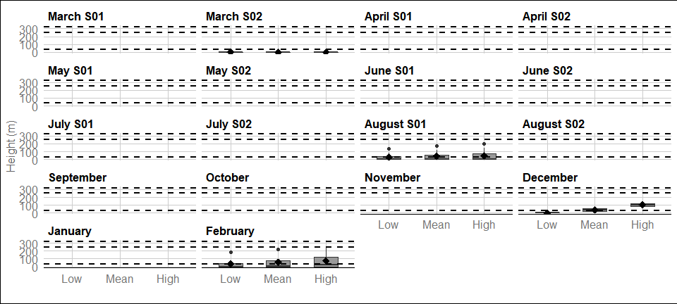

Figure : Distribution of gannet flight heights from minimum (2.5th percentile), mean and maximum (97.5th percentile) bootstrapped estimates in year 2. The mean of the population for each distribution is indicated by the black dot, and the middle line represents the median. The grey boxes represent the middle 50% of the data. The dotted lines indicate the minimum and maximum rotor heights of both wind turbine scenarios.

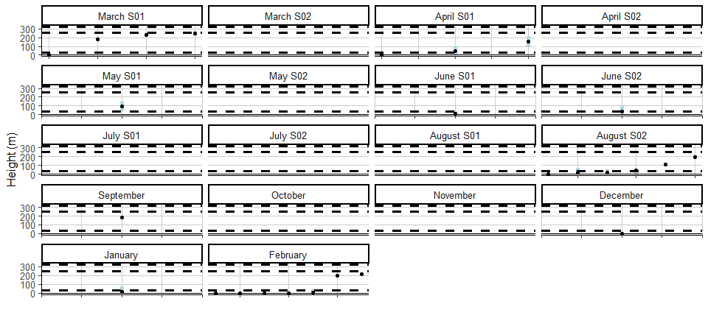

Figure : Ordered height estimates of individual gannet in the survey area with minimum and maximum potential height range for both smallest and largest turbine specifications in year1.

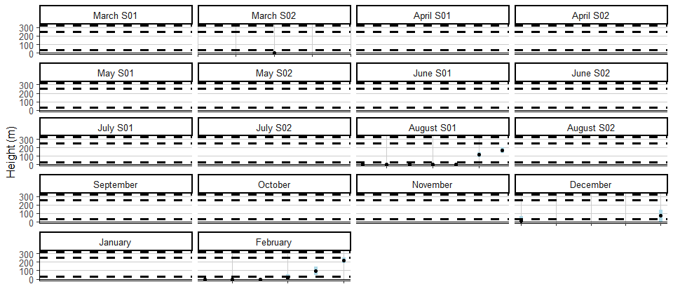

Figure : Ordered height estimates of individual gannet in the survey area with minimum and maximum potential height range for both smallest and largest turbine specifications in year2.

#### Spatial variation in flight height

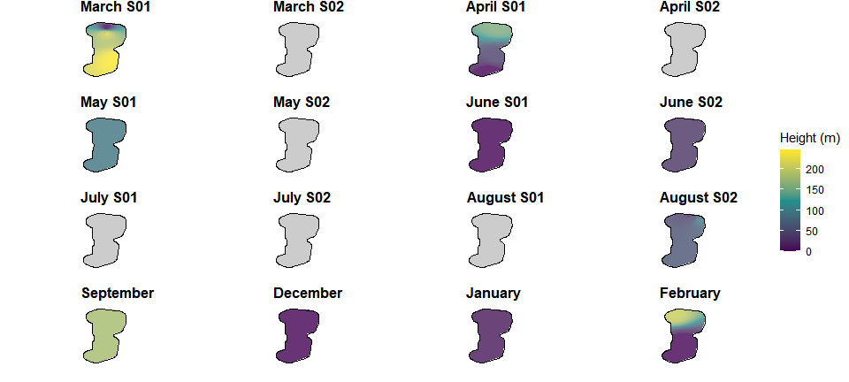

Figure : Two-dimensional spatial variation in estimated mean flight heights of gannet in year 1. Flight height estimates were derived using an inverse distance weighted interpolation. Grey plots indicate months were no birds of this species were recorded.

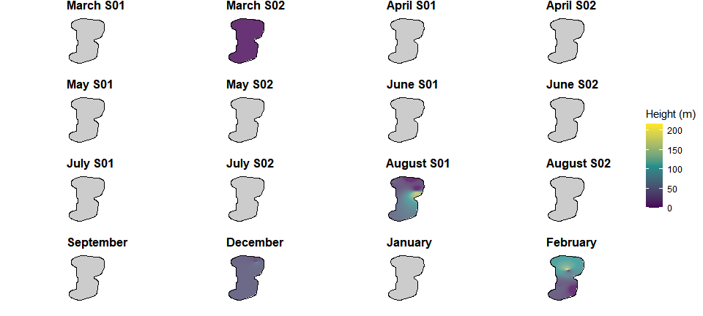

Figure : Two-dimensional spatial variation in estimated mean flight heights of gannet in year 2. Flight height estimates were derived using an inverse distance weighted interpolation. Grey plots indicate months were no birds of this species were recorded.

### Lesser black-backed gull

#### Proportion of birds at PCH

Table : Mean height and proportion (%) of lesser black-backed gull at PCH in year 1. For flight heights both the mean and the interquartile range (IQR), i.e. the middle 50% of the data, are reported for each of the bootstrapped flight height scenarios.

|  | | | | | | | **Proportion of birds at PCH  (%)** | |
| --- | --- | --- | --- | --- | --- | --- | --- | --- |
| **Year** | **Survey** | **Scenario** | **Sample Size  (n)** | **Mean bootstrapped  height estimate  (m)** | **+/- 95% CI** | **Inter-quartile  range** | **Small Scenario  (32 - 252m)** | **Large scenario  (32 - 322m)** |
| Year 1 | March S01 | Low | 1 | 1.3 | (NA-NA) | 1.3-1.3 | 0.0 | 0 |
| Year 1 | Mean | 69.4 | (NA-NA) | 69.4-69.4 | 100.0 | 100 |
| Year 1 | High | 103.1 | (NA-NA) | 103.1-103.1 | 100.0 | 100 |
| Year 1 | March S02 | Low | 11 | 41.6 | (0.6-82.6) | 0-54.8 | 36.4 | 36 |
| Year 1 | Mean | 58.2 | (8.1-108.3) | 1.1-90.2 | 36.4 | 36 |
| Year 1 | High | 104.4 | (51.6-157.2) | 33.8-134.6 | 63.6 | 73 |
| Year 1 | April S01 | Low | 6 | 67.4 | (-8.2-143) | 0-126.5 | 50.0 | 50 |
| Year 1 | Mean | 103.8 | (22.3-185.3) | 19-185.4 | 66.7 | 67 |
| Year 1 | High | 165.4 | (93.5-237.3) | 91.7-240.9 | 66.7 | 100 |
| Year 1 | April S02 | Low | 74.3 | (4.2-144.4) | 4.4-145.5 | 50.0 | 50 |
| Year 1 | Mean | 116.6 | (32.8-200.4) | 26.1-210.7 | 66.7 | 67 |
| Year 1 | High | 168.0 | (93.4-242.6) | 90.3-253 | 66.7 | 100 |
| Year 1 | May S01 | Low | 5 | 30.4 | (-9.6-70.4) | 0-49.6 | 40.0 | 40 |
| Year 1 | Mean | 59.4 | (-2.9-121.7) | 0-116.5 | 40.0 | 40 |
| Year 1 | High | 92.2 | (10.4-174) | 0-172.7 | 60.0 | 60 |
| Year 1 | May S02 | Low | 8 | 34.3 | (1.9-66.7) | 0-52.1 | 37.5 | 38 |
| Year 1 | Mean | 89.1 | (28.4-149.8) | 3.2-174.7 | 62.5 | 62 |
| Year 1 | High | 137.9 | (76.9-198.9) | 56.9-215.6 | 87.5 | 88 |
| Year 1 | June S01 | Low | 22 | 84.5 | (41.6-127.4) | 0-176.3 | 40.9 | 45 |
| Year 1 | Mean | 99.8 | (53.9-145.7) | 0.9-201.6 | 36.4 | 50 |
| Year 1 | High | 132.9 | (87.2-178.6) | 34.5-232.6 | 59.1 | 77 |
| Year 1 | June S02 | Low | 26 | 26.9 | (1.7-52.1) | 0-1 | 15.4 | 15 |
| Year 1 | Mean | 56.8 | (26.9-86.7) | 8.2-66.3 | 42.3 | 46 |
| Year 1 | High | 122.2 | (92.5-151.9) | 72.5-150.9 | 80.8 | 88 |
| Year 1 | July S01 | Low | 10 | 0.0 | (0-0) | 0-0 | 0.0 | 0 |
| Year 1 | Mean | 10.8 | (-2.1-23.7) | 0.1-8.6 | 10.0 | 10 |
| Year 1 | High | 46.2 | (12.7-79.7) | 0.8-66.6 | 50.0 | 50 |
| Year 1 | July S02 | Low | 53 | 19.3 | (6.8-31.8) | 0-0 | 18.9 | 19 |
| Year 1 | Mean | 59.3 | (42.1-76.5) | 5.2-93.7 | 54.7 | 55 |
| Year 1 | High | 122.6 | (104.2-141) | 76.5-171.5 | 84.9 | 91 |
| Year 1 | August S01 | Low | 2 | 0.0 | (0-0) | 0-0 | 0.0 | 0 |
| Year 1 | Mean | 22.2 | (-21.4-65.8) | 11.1-33.4 | 50.0 | 50 |
| Year 1 | High | 76.8 | (-73.7-227.3) | 38.4-115.2 | 50.0 | 50 |
| Year 1 | August S02 | Low | 3 | 0.0 | (-0.1-0.1) | 0-0.1 | 0.0 | 0 |
| Year 1 | Mean | 20.3 | (11-29.6) | 16.2-24.4 | 0.0 | 0 |
| Year 1 | High | 92.0 | (73.6-110.4) | 83.5-99.7 | 100.0 | 100 |
| Year 1 | September | Low | 7 | 39.5 | (-23.2-102.2) | 0-23.4 | 14.3 | 14 |
| Year 1 | Mean | 60.8 | (-1.6-123.2) | 17.8-55.9 | 57.1 | 57 |
| Year 1 | High | 106.9 | (47.8-166) | 66.9-116.3 | 71.4 | 86 |
| Year 1 | December | Low | 2 | 62.8 | (-60.2-185.8) | 31.4-94.2 | 50.0 | 50 |
| Year 1 | Mean | 108.2 | (-86.5-302.9) | 58.5-157.8 | 50.0 | 50 |
| Year 1 | High | 149.4 | (-31-329.8) | 103.4-195.4 | 100.0 | 100 |

Table : Mean height and proportion (%) of lesser black-backed gull at PCH in year 2. For flight heights both the mean and the interquartile range (IQR), i.e. the middle 50% of the data, are reported for each of the bootstrapped flight height scenarios.

|  | | | | | | | **Proportion of birds at PCH  (%)** | |
| --- | --- | --- | --- | --- | --- | --- | --- | --- |
| **Year** | **Survey** | **Scenario** | **Sample Size  (n)** | **Mean bootstrapped  height estimate  (m)** | **+/- 95% CI** | **Inter-quartile  range** | **Small Scenario  (32 - 252m)** | **Large scenario  (32 - 322m)** |
| Year 2 | March S01 | Low | 1 | 71.8 | (NA-NA) | 71.8-71.8 | 100.0 | 100 |
| Year 2 | Mean | 118.4 | (NA-NA) | 118.4-118.4 | 100.0 | 100 |
| Year 2 | High | 155.7 | (NA-NA) | 155.7-155.7 | 100.0 | 100 |
| Year 2 | March S02 | Low | 4 | 55.3 | (-27.9-138.5) | 6.8-68.3 | 25.0 | 25 |
| Year 2 | Mean | 97.7 | (1.1-194.3) | 45.6-113.4 | 75.0 | 75 |
| Year 2 | High | 144.5 | (62.2-226.8) | 102.4-151.2 | 75.0 | 100 |
| Year 2 | April S02 | Low | 10 | 0.0 | (0-0) | 0-0 | 0.0 | 0 |
| Year 2 | Mean | 6.3 | (-1.2-13.8) | 0-6.1 | 10.0 | 10 |
| Year 2 | High | 41.8 | (16.1-67.5) | 7.4-62 | 50.0 | 50 |
| Year 2 | May S01 | Low | 8 | 31.4 | (-16.4-79.2) | 0-15.1 | 25.0 | 25 |
| Year 2 | Mean | 69.9 | (16.1-123.7) | 10.1-85.1 | 62.5 | 62 |
| Year 2 | High | 122.2 | (70-174.4) | 69.7-147 | 87.5 | 88 |
| Year 2 | May S02 | Low | 1 | 0.0 | (NA-NA) | 0-0 | 0.0 | 0 |
| Year 2 | Mean | 15.5 | (NA-NA) | 15.5-15.5 | 0.0 | 0 |
| Year 2 | High | 103.6 | (NA-NA) | 103.6-103.6 | 100.0 | 100 |
| Year 2 | June S01 | Low | 34 | 23.4 | (4.2-42.6) | 0-0.5 | 17.6 | 18 |
| Year 2 | Mean | 55.6 | (30.2-81) | 2.8-94.6 | 35.3 | 38 |
| Year 2 | High | 115.5 | (87.9-143.1) | 51-171.7 | 76.5 | 85 |
| Year 2 | June S02 | Low | 10 | 10.8 | (-3.7-25.3) | 0-9.9 | 10.0 | 10 |
| Year 2 | Mean | 51.2 | (21.7-80.7) | 13.5-69.5 | 50.0 | 50 |
| Year 2 | High | 115.1 | (77-153.2) | 64.6-131 | 90.0 | 90 |
| Year 2 | July S01 | Low | 7 | 9.6 | (-9.2-28.4) | 0-0 | 14.3 | 14 |
| Year 2 | Mean | 48.8 | (7.8-89.8) | 13.1-59.3 | 57.1 | 57 |
| Year 2 | High | 121.7 | (71.6-171.8) | 79.4-148.7 | 85.7 | 86 |
| Year 2 | July S02 | Low | 4 | 0.0 | (0-0) | 0-0 | 0.0 | 0 |
| Year 2 | Mean | 22.5 | (5.2-39.8) | 11.6-35.6 | 50.0 | 50 |
| Year 2 | High | 89.6 | (52.6-126.6) | 70.2-118.8 | 100.0 | 100 |
| Year 2 | August S01 | Low | 3 | 47.5 | (-45.6-140.6) | 0-71.2 | 33.3 | 33 |
| Year 2 | Mean | 94.8 | (-14.8-204.4) | 40.7-133.9 | 66.7 | 67 |
| Year 2 | High | 160.2 | (83.2-237.2) | 123.2-190 | 100.0 | 100 |
| Year 2 | August S02 | Low | 0.0 | (0-0) | 0-0 | 0.0 | 0 |
| Year 2 | Mean | 6.2 | (-4.6-17) | 0.7-9.2 | 0.0 | 0 |
| Year 2 | High | 61.8 | (23.5-100.1) | 42.7-75.1 | 100.0 | 100 |
| Year 2 | September | Low | 4 | 36.0 | (-13-85) | 0-55 | 50.0 | 50 |
| Year 2 | Mean | 94.6 | (26.9-162.3) | 64-127.7 | 75.0 | 75 |
| Year 2 | High | 167.5 | (101-234) | 141.6-203.8 | 100.0 | 100 |
| Year 2 | December | Low | 156.5 | (88.1-224.9) | 129-202.8 | 100.0 | 100 |
| Year 2 | Mean | 185.4 | (124.1-246.7) | 153.5-231.7 | 100.0 | 100 |
| Year 2 | High | 212.8 | (156.2-269.4) | 181.1-257.9 | 50.0 | 100 |
| Year 2 | February | Low | 2 | 0.0 | (0-0) | 0-0 | 0.0 | 0 |
| Year 2 | Mean | 8.8 | (5.2-12.4) | 7.9-9.7 | 0.0 | 0 |
| Year 2 | High | 75.9 | (46-105.8) | 68.2-83.5 | 100.0 | 100 |

#### Flight height ranges

For interpretation of the following graphs, see Section 3.2.

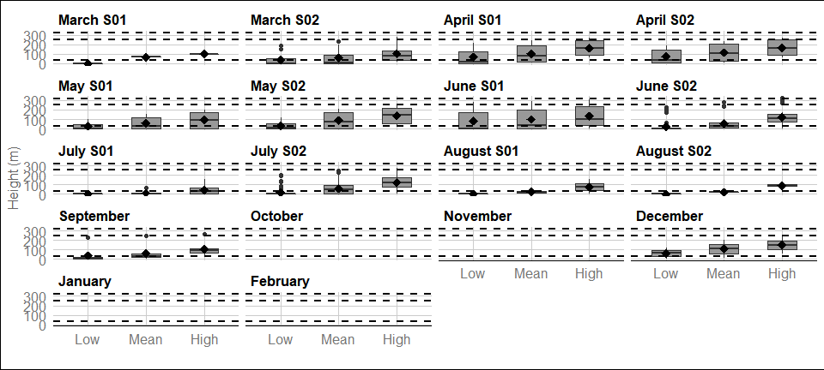

Figure : Distribution of lesser black-backed gull flight heights from minimum (2.5th percentile), mean and maximum (97.5th percentile) bootstrapped estimates in year 1. The mean of the population for each distribution is indicated by the black dot, and the middle line represents the median. The grey boxes represent the middle 50% of the data. The dotted lines indicate the minimum and maximum rotor heights of both wind turbine scenarios.

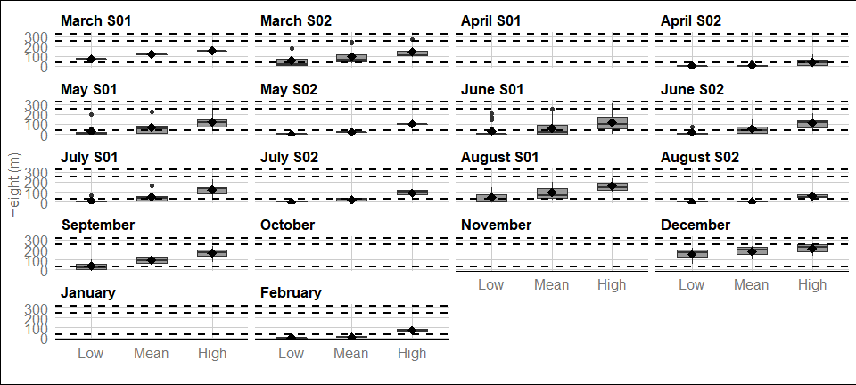

Figure : Distribution of lesser black-backed gull flight heights from minimum (2.5th percentile), mean and maximum (97.5th percentile) bootstrapped estimates in year 2. The mean of the population for each distribution is indicated by the black dot, and the middle line represents the median. The grey boxes represent the middle 50% of the data. The dotted lines indicate the minimum and maximum rotor heights of both wind turbine scenarios.

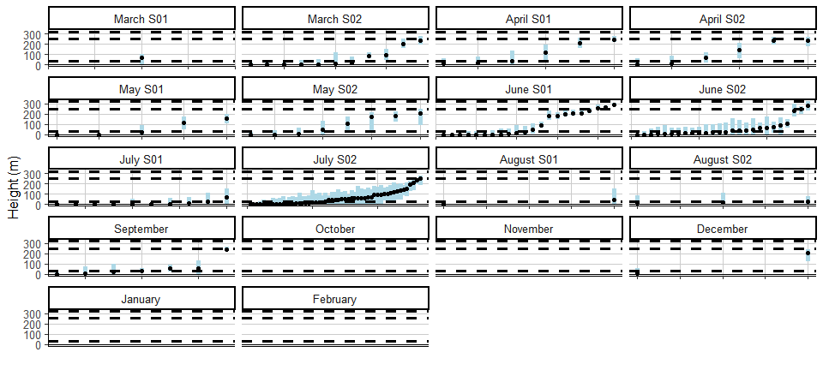

Figure : Ordered height estimates of individual lesser black-backed gull in the survey area with minimum and maximum potential height range for both smallest and largest turbine specifications in year1.

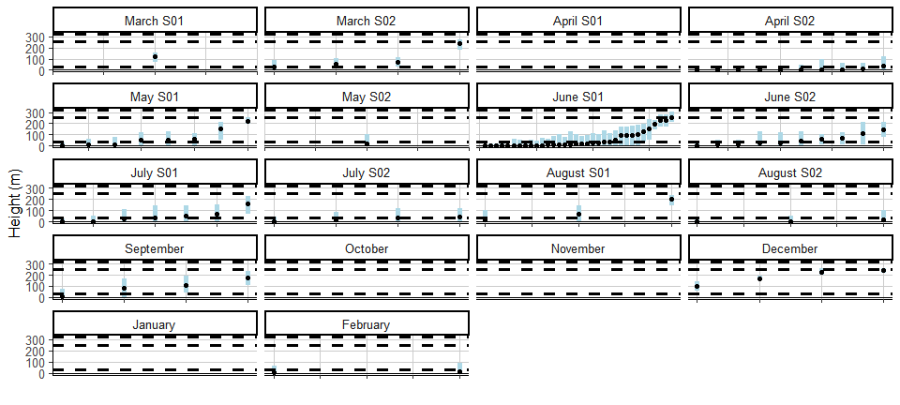

Figure : Ordered height estimates of individual lesser black-backed gull in the survey area with minimum and maximum potential height range for both smallest and largest turbine specifications in year2.

#### Spatial variation in flight height

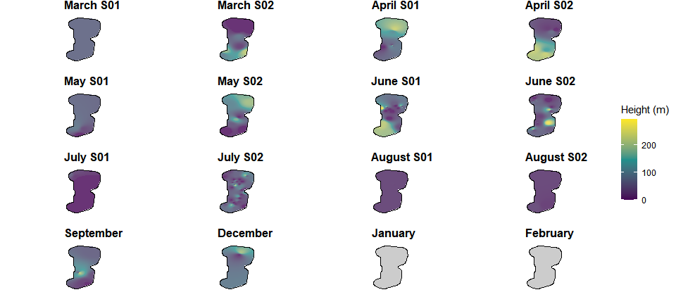

Figure : Two-dimensional spatial variation in estimated mean flight heights of lesser black-backed gull in year 1. Flight height estimates were derived using an inverse distance weighted interpolation. Grey plots indicate months were no birds of this species were recorded.

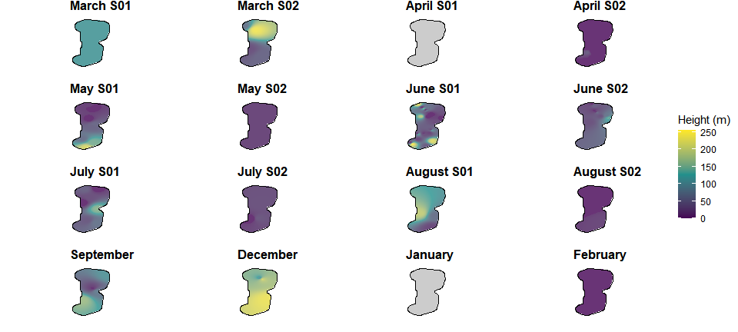

Figure : Two-dimensional spatial variation in estimated mean flight heights of lesser black-backed gull in year 2. Flight height estimates were derived using an inverse distance weighted interpolation. Grey plots indicate months were no birds of this species were recorded.

### Great black-backed gull

#### Proportion of birds at PCH

Table : Mean height and proportion (%) of great black-backed gull at PCH in year 1. For flight heights both the mean and the interquartile range (IQR), i.e. the middle 50% of the data, are reported for each of the bootstrapped flight height scenarios.

|  | | | | | | | **Proportion of birds at PCH  (%)** | |
| --- | --- | --- | --- | --- | --- | --- | --- | --- |
| **Year** | **Survey** | **Scenario** | **Sample Size  (n)** | **Mean bootstrapped  height estimate  (m)** | **+/- 95% CI** | **Inter-quartile  range** | **Small Scenario  (32 - 252m)** | **Large scenario  (32 - 322m)** |
| Year 1 | March S01 | Low | 2 | 2.4 | (-2.3-7.1) | 1.2-3.6 | 0.0 | 0 |
| Year 1 | Mean | 26.0 | (21.8-30.2) | 24.9-27.1 | 0.0 | 0 |
| Year 1 | High | 55.3 | (42.7-67.9) | 52.1-58.5 | 100.0 | 100 |
| Year 1 | March S02 | Low | 3 | 42.7 | (-28.6-114) | 6.5-64 | 33.3 | 33 |
| Year 1 | Mean | 72.9 | (-10.3-156.1) | 35.8-109.3 | 66.7 | 67 |
| Year 1 | High | 102.6 | (-2.1-207.3) | 64-153.9 | 66.7 | 67 |
| Year 1 | April S01 | Low | 0.0 | (0-0) | 0-0 | 0.0 | 0 |
| Year 1 | Mean | 7.7 | (-7.4-22.8) | 0-11.5 | 0.0 | 0 |
| Year 1 | High | 36.7 | (-32.9-106.3) | 1.2-55.1 | 33.3 | 33 |
| Year 1 | April S02 | Low | 5 | 13.3 | (-12.8-39.4) | 0-0 | 20.0 | 20 |
| Year 1 | Mean | 27.1 | (-25-79.2) | 0-1.4 | 20.0 | 20 |
| Year 1 | High | 46.9 | (-20.2-114) | 0-30.8 | 20.0 | 20 |
| Year 1 | May S02 | Low | 6 | 12.3 | (-11.9-36.5) | 0-0 | 16.7 | 17 |
| Year 1 | Mean | 30.9 | (-9.7-71.5) | 2.9-26.2 | 16.7 | 17 |
| Year 1 | High | 76.9 | (26.5-127.3) | 39.5-95.6 | 66.7 | 67 |
| Year 1 | June S01 | Low | 1 | 198.0 | (NA-NA) | 198-198 | 100.0 | 100 |
| Year 1 | Mean | 213.1 | (NA-NA) | 213.1-213.1 | 100.0 | 100 |
| Year 1 | High | 222.9 | (NA-NA) | 222.9-222.9 | 100.0 | 100 |
| Year 1 | July S02 | Low | 4 | 21.4 | (-20.6-63.4) | 0-21.4 | 25.0 | 25 |
| Year 1 | Mean | 35.3 | (-32.3-102.9) | 0.7-35.8 | 25.0 | 25 |
| Year 1 | High | 67.7 | (-19.8-155.2) | 24.2-78.6 | 50.0 | 50 |
| Year 1 | September | Low | 3 | 22.4 | (-4.4-49.2) | 9.9-33.5 | 33.3 | 33 |
| Year 1 | Mean | 35.3 | (-5.5-76.1) | 16.9-53 | 66.7 | 67 |
| Year 1 | High | 49.1 | (-9.8-108) | 21.8-73.6 | 66.7 | 67 |
| Year 1 | December | Low | 1 | 143.3 | (NA-NA) | 143.3-143.3 | 100.0 | 100 |
| Year 1 | Mean | 176.2 | (NA-NA) | 176.2-176.2 | 100.0 | 100 |
| Year 1 | High | 213.1 | (NA-NA) | 213.1-213.1 | 100.0 | 100 |

Table : Mean height and proportion (%) of great black-backed gull at PCH in year 2. For flight heights both the mean and the interquartile range (IQR), i.e. the middle 50% of the data, are reported for each of the bootstrapped flight height scenarios.

|  | | | | | | | **Proportion of birds at PCH  (%)** | |
| --- | --- | --- | --- | --- | --- | --- | --- | --- |
| **Year** | **Survey** | **Scenario** | **Sample Size  (n)** | **Mean bootstrapped  height estimate  (m)** | **+/- 95% CI** | **Inter-quartile  range** | **Small Scenario  (32 - 252m)** | **Large scenario  (32 - 322m)** |
| Year 2 | March S01 | Low | 2 | 102.4 | (-98.3-303.1) | 51.2-153.6 | 50.0 | 50 |
| Year 2 | Mean | 120.3 | (-100-340.6) | 64.1-176.4 | 50.0 | 50 |
| Year 2 | High | 150.4 | (-60.8-361.6) | 96.6-204.3 | 50.0 | 100 |
| Year 2 | July S02 | Low | 1 | 0.0 | (NA-NA) | 0-0 | 0.0 | 0 |
| Year 2 | Mean | 1.5 | (NA-NA) | 1.5-1.5 | 0.0 | 0 |
| Year 2 | High | 37.8 | (NA-NA) | 37.8-37.8 | 100.0 | 100 |
| Year 2 | August S02 | Low | 0.0 | (NA-NA) | 0-0 | 0.0 | 0 |
| Year 2 | Mean | 1.0 | (NA-NA) | 1-1 | 0.0 | 0 |
| Year 2 | High | 19.1 | (NA-NA) | 19.1-19.1 | 0.0 | 0 |
| Year 2 | September | Low | 0.0 | (NA-NA) | 0-0 | 0.0 | 0 |
| Year 2 | Mean | 2.0 | (NA-NA) | 2-2 | 0.0 | 0 |
| Year 2 | High | 41.4 | (NA-NA) | 41.4-41.4 | 100.0 | 100 |
| Year 2 | December | Low | 15 | 18.7 | (1.8-35.6) | 0-26.9 | 26.7 | 27 |
| Year 2 | Mean | 33.3 | (10.2-56.4) | 0-60.9 | 40.0 | 40 |
| Year 2 | High | 53.3 | (24.9-81.7) | 6.5-98.5 | 46.7 | 47 |

#### Flight height ranges

For interpretation of the following graphs, see Section 3.2.

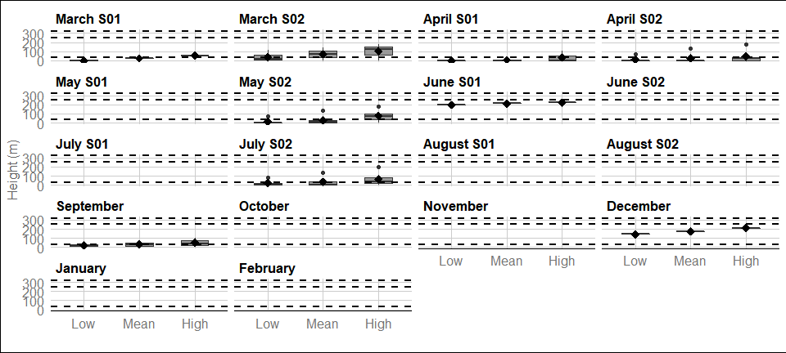

Figure : Distribution of great black-backed gull flight heights from minimum (2.5th percentile), mean and maximum (97.5th percentile) bootstrapped estimates in year 1. The mean of the population for each distribution is indicated by the black dot, and the middle line represents the median. The grey boxes represent the middle 50% of the data. The dotted lines indicate the minimum and maximum rotor heights of both wind turbine scenarios.

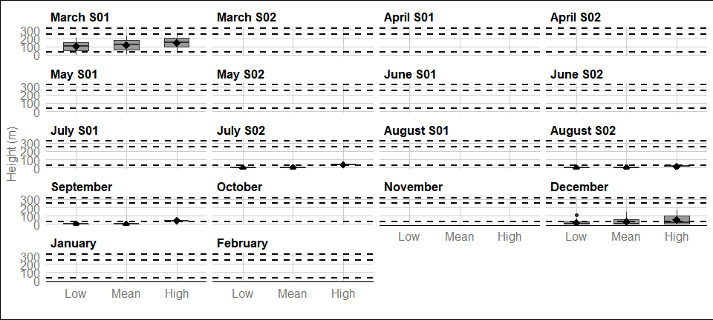

Figure : Distribution of great black-backed gull flight heights from minimum (2.5th percentile), mean and maximum (97.5th percentile) bootstrapped estimates in year 2. The mean of the population for each distribution is indicated by the black dot, and the middle line represents the median. The grey boxes represent the middle 50% of the data. The dotted lines indicate the minimum and maximum rotor heights of both wind turbine scenarios.

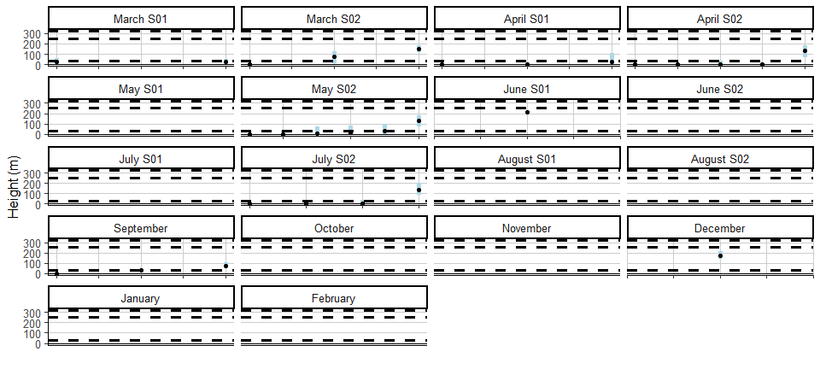

Figure : Ordered height estimates of individual great black-backed gull in the survey area with minimum and maximum potential height range for both smallest and largest turbine specifications in year1.

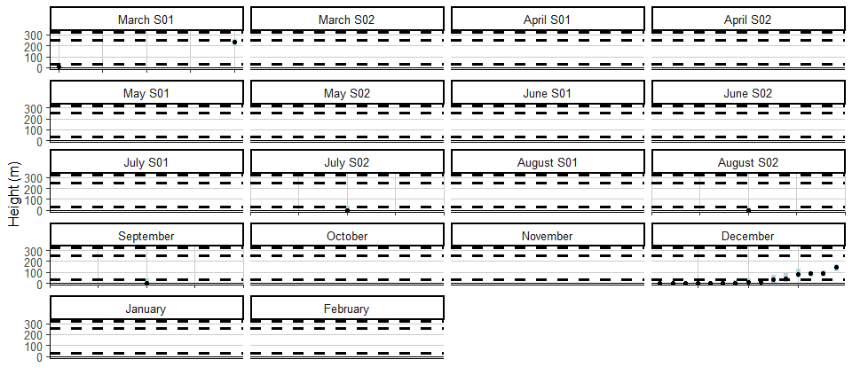

Figure : Ordered height estimates of individual great black-backed gull in the survey area with minimum and maximum potential height range for both smallest and largest turbine specifications in year2.

#### Spatial variation in flight height

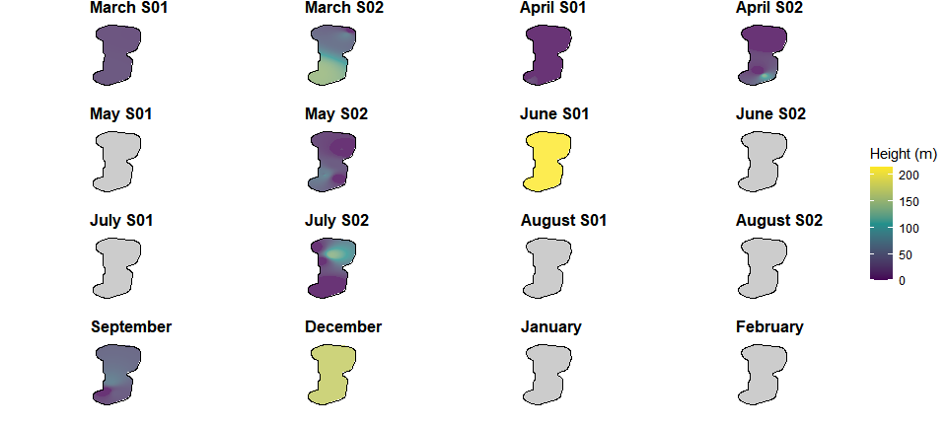

Figure : Two-dimensional spatial variation in estimated mean flight heights of great black-backed gull in year 1. Flight height estimates were derived using an inverse distance weighted interpolation. Grey plots indicate months were no birds of this species were recorded.

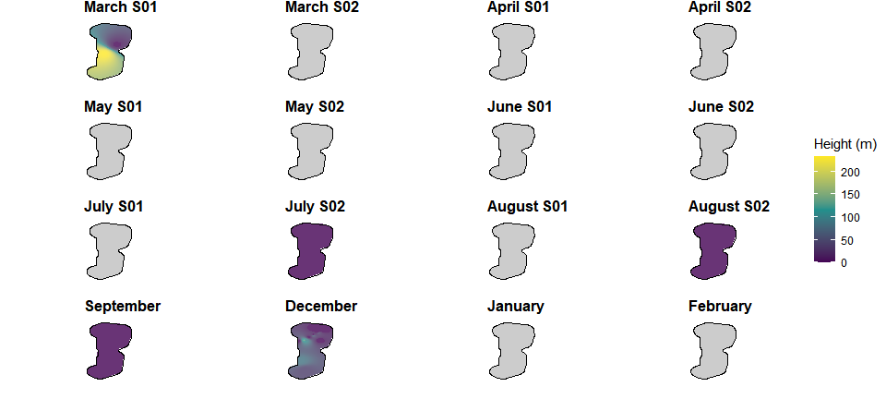

Figure : Two-dimensional spatial variation in estimated mean flight heights of great black-backed gull in year 2. Flight height estimates were derived using an inverse distance weighted interpolation. Grey plots indicate months were no birds of this species were recorded.

### Herring gull

#### Proportion of birds at PCH

Table : Mean height and proportion (%) of herring gull at PCH in year 1. For flight heights both the mean and the interquartile range (IQR), i.e. the middle 50% of the data, are reported for each of the bootstrapped flight height scenarios.

|  | | | | | | | **Proportion of birds at PCH  (%)** | |
| --- | --- | --- | --- | --- | --- | --- | --- | --- |
| **Year** | **Survey** | **Scenario** | **Sample Size  (n)** | **Mean bootstrapped  height estimate  (m)** | **+/- 95% CI** | **Inter-quartile  range** | **Small Scenario  (32 - 252m)** | **Large scenario  (32 - 322m)** |
| Year 1 | March S02 | Low | 2 | 0.6 | (-0.7-1.9) | 0.3-1 | 0.0 | 0 |
| Year 1 | Mean | 76.4 | (59.2-93.6) | 72-80.8 | 100.0 | 100 |
| Year 1 | High | 125.4 | (112.9-137.9) | 122.2-128.6 | 100.0 | 100 |
| Year 1 | April S02 | Low | 1 | 95.8 | (NA-NA) | 95.8-95.8 | 100.0 | 100 |
| Year 1 | Mean | 143.2 | (NA-NA) | 143.2-143.2 | 100.0 | 100 |
| Year 1 | High | 184.4 | (NA-NA) | 184.4-184.4 | 100.0 | 100 |
| Year 1 | June S01 | Low | 2 | 35.8 | (-34.3-105.9) | 17.9-53.7 | 50.0 | 50 |
| Year 1 | Mean | 54.9 | (-52.7-162.5) | 27.4-82.3 | 50.0 | 50 |
| Year 1 | High | 70.8 | (-68-209.6) | 35.4-106.2 | 50.0 | 50 |
| Year 1 | June S02 | Low | 3 | 27.1 | (-26-80.2) | 0-40.6 | 33.3 | 33 |
| Year 1 | Mean | 72.8 | (-59.3-204.9) | 5.4-107.6 | 33.3 | 33 |
| Year 1 | High | 137.6 | (-16.4-291.6) | 60.6-189.8 | 66.7 | 100 |
| Year 1 | August S01 | Low | 5 | 0.0 | (0-0) | 0-0 | 0.0 | 0 |
| Year 1 | Mean | 0.0 | (0-0) | 0-0 | 0.0 | 0 |
| Year 1 | High | 0.0 | (0-0) | 0-0 | 0.0 | 0 |
| Year 1 | September | Low | 1 | 0.0 | (NA-NA) | 0-0 | 0.0 | 0 |
| Year 1 | Mean | 0.0 | (NA-NA) | 0-0 | 0.0 | 0 |
| Year 1 | High | 0.0 | (NA-NA) | 0-0 | 0.0 | 0 |
| Year 1 | December | Low | 0.0 | (NA-NA) | 0-0 | 0.0 | 0 |
| Year 1 | Mean | 0.8 | (NA-NA) | 0.8-0.8 | 0.0 | 0 |
| Year 1 | High | 23.1 | (NA-NA) | 23.1-23.1 | 0.0 | 0 |
| Year 1 | January | Low | 0.0 | (NA-NA) | 0-0 | 0.0 | 0 |
| Year 1 | Mean | 0.0 | (NA-NA) | 0-0 | 0.0 | 0 |
| Year 1 | High | 0.3 | (NA-NA) | 0.3-0.3 | 0.0 | 0 |

Table : Mean height and proportion (%) of herring gull at PCH in year 2. For flight heights both the mean and the interquartile range (IQR), i.e. the middle 50% of the data, are reported for each of the bootstrapped flight height scenarios.

|  | | | | | | | **Proportion of birds at PCH  (%)** | |
| --- | --- | --- | --- | --- | --- | --- | --- | --- |
| **Year** | **Survey** | **Scenario** | **Sample Size  (n)** | **Mean bootstrapped  height estimate  (m)** | **+/- 95% CI** | **Inter-quartile  range** | **Small Scenario  (32 - 252m)** | **Large scenario  (32 - 322m)** |
| Year 2 | April S01 | Low | 2 | 14.7 | (-14-43.4) | 7.3-22 | 0 | 0 |
| Year 2 | Mean | 33.0 | (-0.2-66.2) | 24.5-41.5 | 50 | 50 |
| Year 2 | High | 97.4 | (74.7-120.1) | 91.6-103.2 | 100 | 100 |
| Year 2 | April S02 | Low | 0.0 | (0-0) | 0-0 | 0 | 0 |
| Year 2 | Mean | 2.1 | (-2.1-6.3) | 1.1-3.2 | 0 | 0 |
| Year 2 | High | 22.0 | (-21-65) | 11-32.9 | 50 | 50 |
| Year 2 | June S02 | Low | 1 | 0.0 | (NA-NA) | 0-0 | 0 | 0 |
| Year 2 | Mean | 51.1 | (NA-NA) | 51.1-51.1 | 100 | 100 |
| Year 2 | High | 123.5 | (NA-NA) | 123.5-123.5 | 100 | 100 |
| Year 2 | August S02 | Low | 0.0 | (NA-NA) | 0-0 | 0 | 0 |
| Year 2 | Mean | 11.6 | (NA-NA) | 11.6-11.6 | 0 | 0 |
| Year 2 | High | 42.5 | (NA-NA) | 42.5-42.5 | 100 | 100 |
| Year 2 | December | Low | 2 | 22.1 | (-21.1-65.3) | 11-33.1 | 50 | 50 |
| Year 2 | Mean | 46.1 | (-27-119.2) | 27.5-64.8 | 50 | 50 |
| Year 2 | High | 86.5 | (17.8-155.2) | 68.9-104 | 100 | 100 |
| Year 2 | February | Low | 1 | 0.0 | (NA-NA) | 0-0 | 0 | 0 |
| Year 2 | Mean | 8.3 | (NA-NA) | 8.3-8.3 | 0 | 0 |
| Year 2 | High | 73.9 | (NA-NA) | 73.9-73.9 | 100 | 100 |

#### Flight height ranges

For interpretation of the following graphs, see Section 3.2.

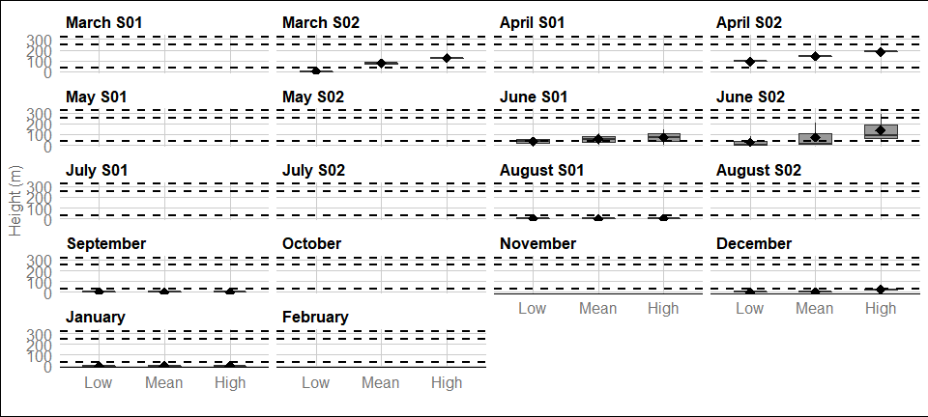

Figure : Distribution of herring gull flight heights from minimum (2.5th percentile), mean and maximum (97.5th percentile) bootstrapped estimates in year 1. The mean of the population for each distribution is indicated by the black dot, and the middle line represents the median. The grey boxes represent the middle 50% of the data. The dotted lines indicate the minimum and maximum rotor heights of both wind turbine scenarios.

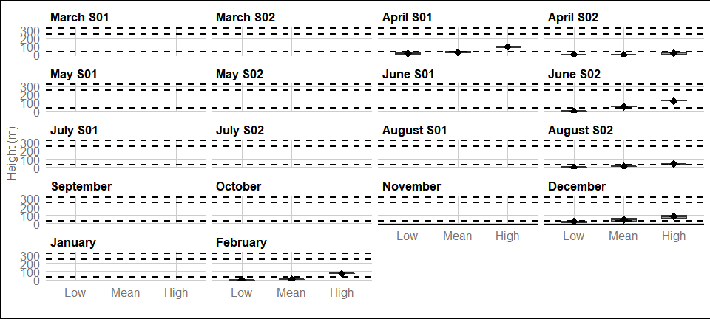

Figure : Distribution of herring gull flight heights from minimum (2.5th percentile), mean and maximum (97.5th percentile) bootstrapped estimates in year 2. The mean of the population for each distribution is indicated by the black dot, and the middle line represents the median. The grey boxes represent the middle 50% of the data. The dotted lines indicate the minimum and maximum rotor heights of both wind turbine scenarios.

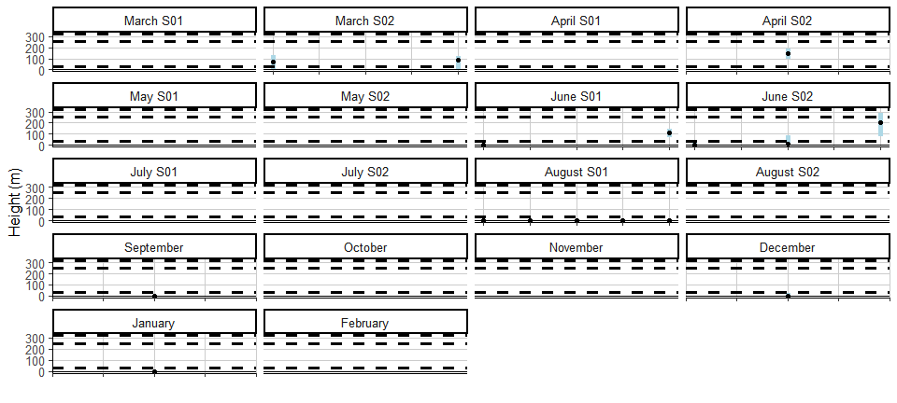

Figure : Ordered height estimates of individual herring gull in the survey area with minimum and maximum potential height range for both smallest and largest turbine specifications in year1.

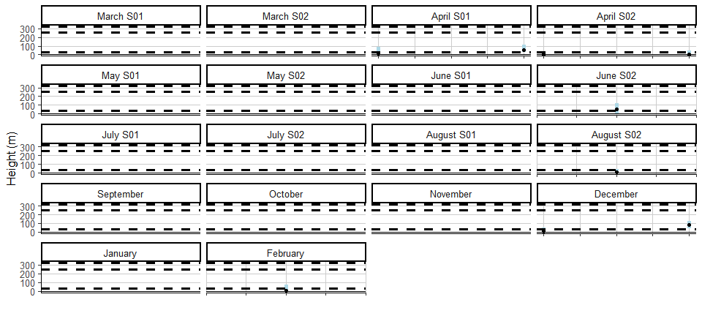

Figure : Ordered height estimates of individual herring gull in the survey area with minimum and maximum potential height range for both smallest and largest turbine specifications in year2.

#### Spatial variation in flight height

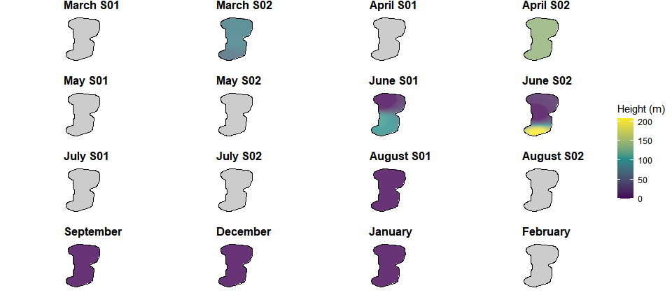

Figure : Two-dimensional spatial variation in estimated mean flight heights of herring gull in year 1. Flight height estimates were derived using an inverse distance weighted interpolation. Grey plots indicate months were no birds of this species were recorded.

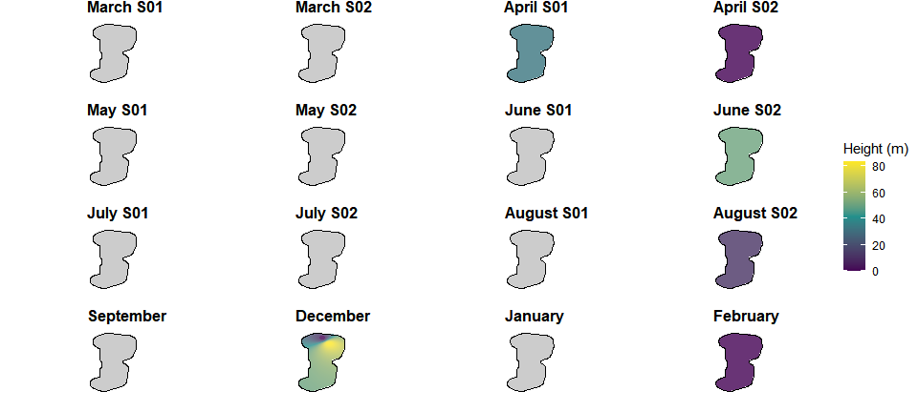

Figure : Two-dimensional spatial variation in estimated mean flight heights of herring gull in year 2. Flight height estimates were derived using an inverse distance weighted interpolation. Grey plots indicate months were no birds of this species were recorded.